Add Class to Admin Area Side Bar

Contents

1. Introduction 2

2. Adding folder in folder 3

# 1. Introduction

This tool is for adding folders in a folder in Control Panel like is shown in the example:

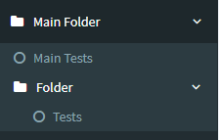

# 2. Adding folder in folder

For example, we want to add a folder “Folder” into “MainFolder”:

1. In lib\Tools\AdminArea\AdminAreaGroupenum.cs add:

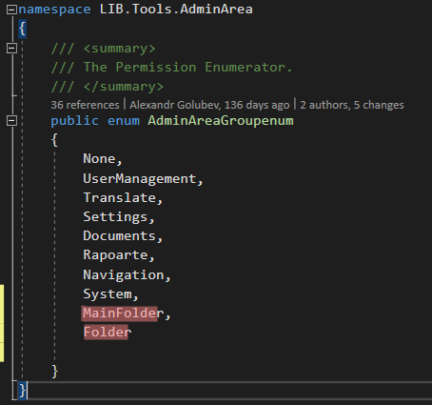

2. In MedProjectLib\Tools\AdminArea\AdminAreaGroup.cs add:

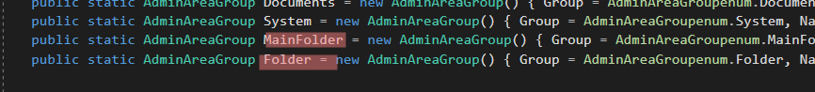

public static AdminAreaGroup MainFolder = new AdminAreaGroup() { Group = AdminAreaGroupenum.MainFolder, Name = LIB.Tools.Utils.Translate.GetTranslatedValue("Main Folder", "BO") };

public static AdminAreaGroup Folder = new AdminAreaGroup() { Group = AdminAreaGroupenum.Folder, Name = LIB.Tools.Utils.Translate.GetTranslatedValue("Folder", "BO") , Parent = MainFolder };

And near add the next part of code:

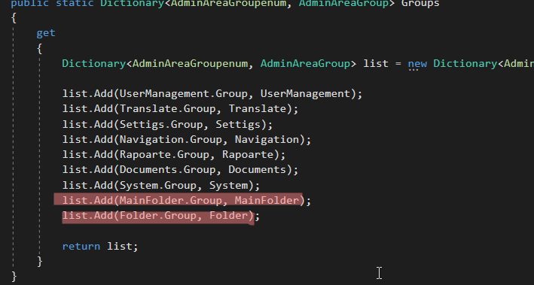

list.Add(MainFolder.Group, MainFolder);

list.Add(Folder.Group, Folder);

3. Add in the class that will be the main folder the next code:

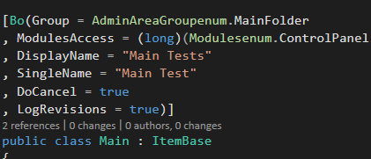

* It is very important in the main folder to exist a class, than the secondary folder will appear

4. Add in the class that will be situated in secondary folder the next code:

